Solution of the generic question - configure with unlimited depth

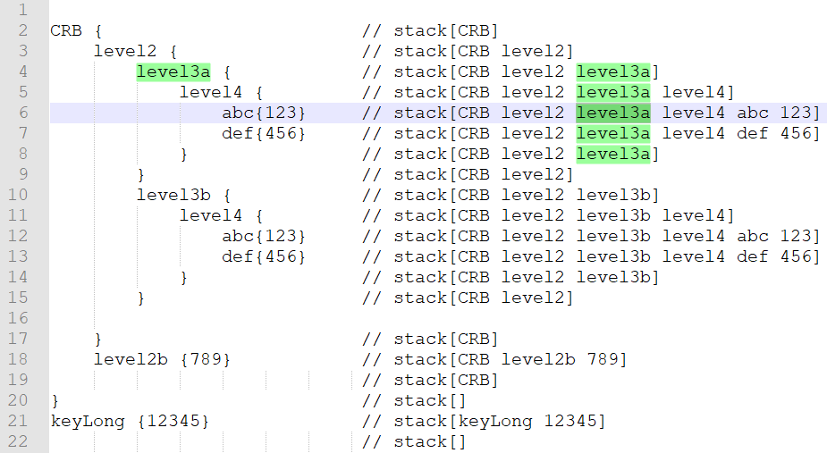

The idea is using stack,

{ which mean push a key into the stack, and go into a deeper level

} which mean pop up a key from the stack, at the same time we have a key:value mapping.

The time complex is linear, O(n), to build all the mapping of leaf nodes.

To support the middle level query, for example find keys of CRB.level2.level3b,

Tree is built, and find the keys is DFS traversal of the tree.

For example, std::vector<std::string> getKey(“CRB.MarketData”):

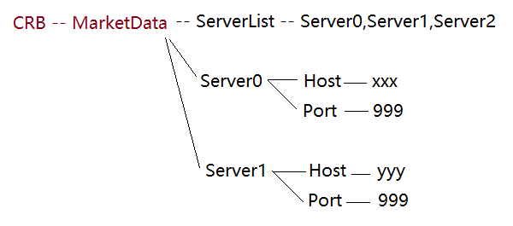

Step 1: find the path;

Step 2: DFS( treenode = MarketData ) to visit all the leaves;